Using Newton’s Second Law:

Apparent Weight Practice

1. Construct the FBD for a person in an elevator:

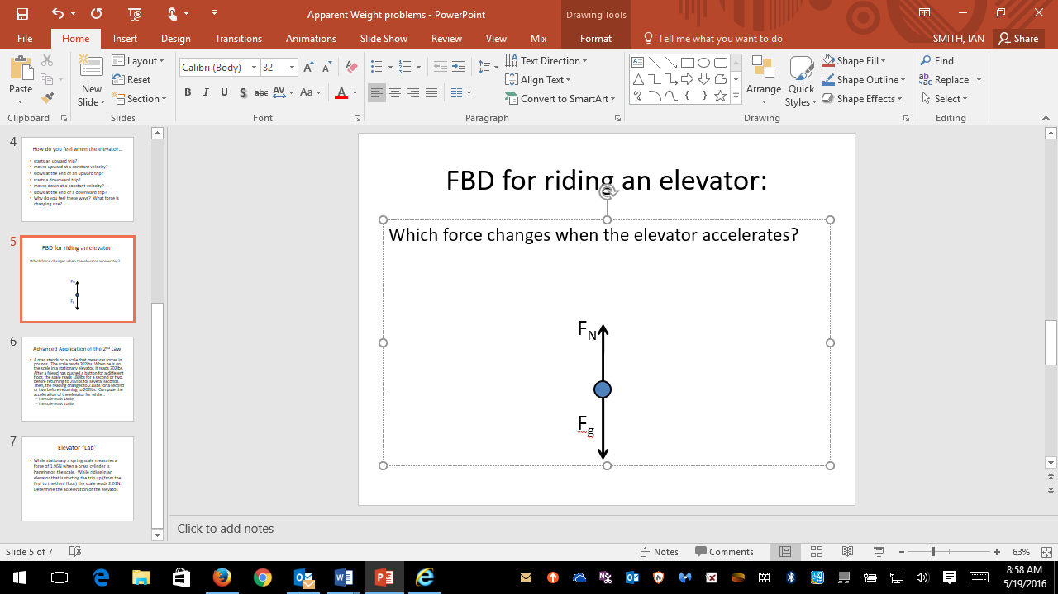

1. Will the normal force always balance the gravitational force? Explain. NO – NOT IF THE ELEVATOR IS ACCELERATING!
2. “Expand” Newton’s Second Law (F=ma) based on the FBD you made. Remember that up is the positive direction!

F = ma becomes FN – Fg = ma

1. Determine the person’s apparent weight or how heavy they feel (the size of the normal force on them) in each of the following situations:
2. A 50kg person in an elevator that is accelerating downward at a rate of 0.75m/s/s. 452.5N
3. A 50 kg person riding an elevator that is moving down at a constant 1.5m/s. 490N
4. A 50kg person riding an elevator that is accelerating upward at 2.0m/s/s. 590N
5. A 100kg person rides in an elevator that is moving up and gaining 1.5m/s each second. 1130N
6. A 100 kg person riding in an elevator that is moving upward at a constant 3.0m/s. 980N
7. A 100kg person riding an elevator that is moving upward, but slowing by 0.5m/s each second. 930N